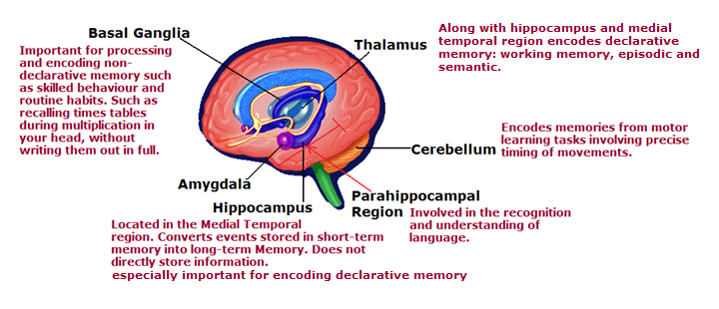
Memory is Stored long-term in many regions of the cerebral Cortex however specific areas are responsible for converting short-term memory into different types of long-term memory. The hippocampal region is associated with the encoding of all forms of memory. Proof for this is seen when Impairment to this region occurs with accidents or ECT electro convulsive therapy or “shock” therapy results in temporary loss of memory for events up to 2-3 years before the session. Also expiremental test scores performed after therapy show impaired cognitive and learning abilities.
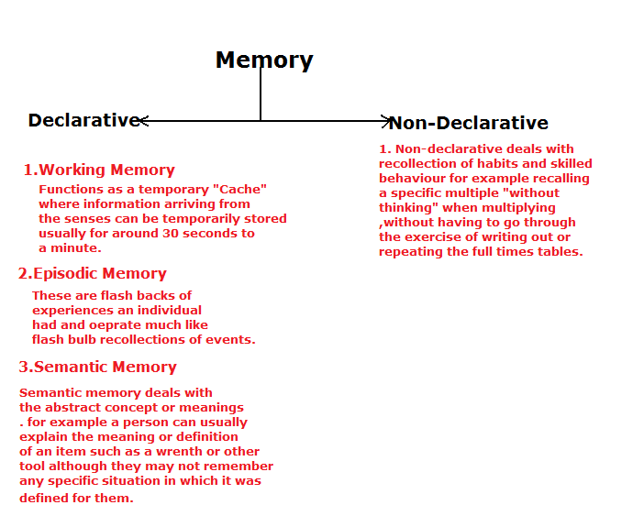
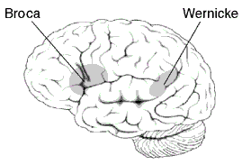
Translates thought into speech The Broca’s area Stores the information concerning the precise set of movements positions and tension of the vochal chords for producing each syllable.
Malfunction here results in a highly frustrating condition called Aphasia (or a disturbance in language production or comprehension) However in people with a malfunction of Broca’s area They understand what people are saying to them but have difficulty forming sensible speech. The person knows what they want to say but whenever they activate their vochal chords, gibberish comes out.
Attaches meaning to audible speech and words you read. Wernicke’s area is responsible for speech recognition and also part of the pathway for recognizing written language. It provides the meaning to the words you read and the speech you hear.
Malfunction also results in Aphasia or (see side note on Broca’s area)

NOTE: BROCA’S AND WERNICKE’S AREAS ARE ONLY IN THE LEFT HEMISPHERE.

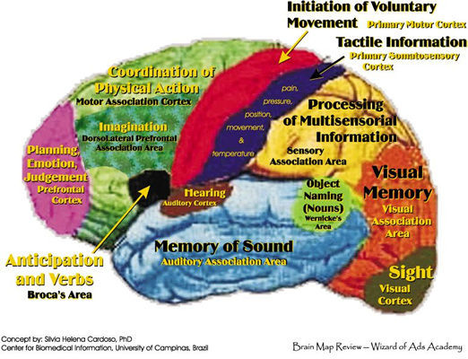

Note: Information which is very familiar to us can be passed on without being interpreted by Wernicke’s or other auditory comprehensive areas. Evidence for this comes from Positron emission tomography studies where radioactive isotopes are injected into the Cerebrospinal fluid of the brain. When cells become metabolically active they break down the isotope, releasing radiation only from areas which are active. Sensors positioned in 360⁰ around the brain pick up which areas of the brain are releasing more or less radiation and know that this corresponds to areas which are being actively uses.
Usually the researchers will ask the subject to perform simple tasks, such as read a book, recite lines or remember a sequence of letters to see which areas light up with emitted radiation and show which areas of the brain are responsible for visual recognition, audible comprehension or memory.

